**FOR IMMEDIATE RELEASE:**

**Media Contact:** Liesl Davenport

**Phone:** 216-640-8677

**Email:** [liesl.davenport@playhousesquare.org](mailto:liesl.davenport@playhousesquare.org)

COMEDIAN JIMMY CARR ANNOUNCES NEW 2025 TOUR

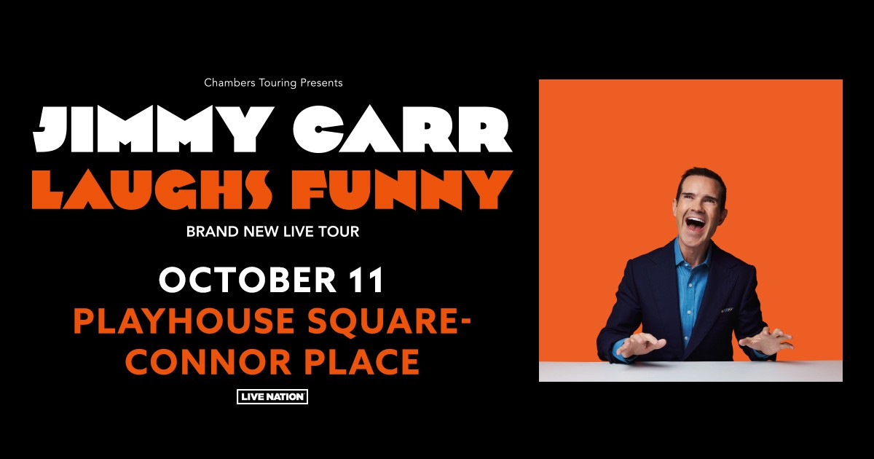‘LAUGHS FUNNY’

*Tickets available now at* [*www.playhousesquare.org*](http://www.playhousesquare.org)

If you like fast-paced, edgy one-liners then get ready to be happy. **Jimmy Carr,** one of the biggest-selling comedians, is going back on tour with his brand-new tour ‘Jimmy Carr: Laughs Funny,' making stops across the United States. The 40+ date tour kicks off on Wednesday, May 21 in Denver, CO at Paramount Theatre, with additional stops in Las Vegas, Seattle, Chicago, New York, Nashville, Cleveland and more before wrapping up on Friday, November 7 in Bethlehem, PA at Wind Creek Event Center.

# Tickets are available now at [www.playhousesqaure.org](http://www.playhousesqaure.org) The performance will be on October 11, 2025, at 7:00 PM. Tickets will be available online at playhousesquare.org or by calling 216-241-6000. Group orders of 10 or more may be placed by calling 216-640-8600. Performance Age Restriction for Laughs Funny: (16+).

Jimmy tells jokes, and jokes are like magnets. Jokes attract people, but they can also repel.

Some people are repelled by Jimmy's dark brand of comedy. This show is not for them.

But if it's the kind of thing you like, then this is the kind of thing you’ll like.

At the latest count he has toured to 45 different countries and his last tour, Terribly Funny, sold over 1.2 million tickets globally.

# ABOUT JIMMY CARR:

Jimmy is a household name in UK television, well known for hosting Channel 4’s 8 Out Of 10 Cats, 8 Out Of 10 Cats Does Countdown and Big Fat Quiz Of The Year in addition to presenting Comedy Central’s Roast Battle UK and Your Face Or Mine. He is a regular on all the top panel shows, including QI and A League Of Their Own, has performed as part of The Royal Variety Performance three times, hosts Channel 4 gameshow I Literally Just Told You and in 2025 will also host Last One Laughing UK on Amazon Prime.

Jimmy is also a high-profile name in North America. He was the first UK comedian to sign a stand-up deal with streaming behemoth Netflix in 2015, releasing four specials on the platform, Funny Business (2016) and Best Of Ultimate Gold Greatest Hits (2017), **His Dark Material** (2021) and **Natural Born Killer** (2024). He also presented and exec-produced an original panel show format for Netflix, The Fix, and has been a guest multiple times on US staples such The Tonight Show, The Late, Late Show and Late Night With Conan O’Brien. He has performed at the Montreal Just ForLaughs Comedy Festival since 2003 with more appearances than any other UK act in that time.

Before making the move to streaming, Jimmy was one of the bestselling acts in the comedy DVD market, his eight titles (Live, Stand-Up, Comedian, In Concert, Telling Jokes, Making People Laugh, Being Funny and Laughing & Joking) selling over 1.2 million copies between them. These shows are now all available on Jimmy’s YouTube channel, where he has accrued over 1.1 million subscribers and 436 million views since launching in 2018.

Jimmy is also a published author. He co-wrote The Naked Jape: Uncovering the Hidden World of Jokes in 2007 and his highly anticipated memoir Before & Laughter was released in September 2021, making The Sunday Times Bestsellers list.

**JIMMY CARR: LAUGHS FUNNY 2025 TOUR DATES:**

Wed May 21 - Denver, CO - Paramount Theatre

Thu May 22 - Reno, NV - Silver Legacy Resort Casino

Fri May 23 - Las Vegas, NV - Encore Theater at Wynn Las Vegas

Sat May 24 - Phoenix, AZ - Celebrity Theatre

Sun May 25 - Rancho Mirage, CA - The Show at Agua Caliente Casino Rancho Mirage

Tue May 27 - Seattle, WA - Moore Theatre

Wed May 28 - Portland, OR - Revolution Hall

Thu May 29 - Los Angeles, CA - The Wiltern

Fri May 30 - San Francisco, CA - The Masonic

Sat May 31 - San Diego, CA - Balboa Theatre

Fri Jun 20 - Chicago, IL - Chicago Theatre Sat

Jun 21 - Detroit, MI - The Fillmore Detroit Sun

Jun 22 - Pittsburgh, PA - Byham Theater

Mon Jun 23 - Philadelphia, PA - Miller Theater

Tues Jun 24 - New Haven, CT - College Street Music Hall Wed

Jun 25 - Huntington, NY - The Paramount

Thu Jun 26 - Boston, MA - Boch Center Wang Theatre

Fri Jun 27 - New York, NY - Beacon Theatre

Sat Jun 28 - Atlantic City, NJ - Music Box at Borgata

Sun Jun 29 - Washington, DC - Warner Theatre Wed

Sep 17 - St. Louis, MO - The Pageant

Thu Sep 18 - Houston, TX - Bayou Music Center

Fri Sep 19 - San Antonio, TX - The Aztec Theater

Sat Sep 20 - Austin, TX - The Paramount Theatre

Sun Sep 21 - Dallas, TX - Majestic Theatre

Tue Sep 23 - Hollywood, FL - Hard Rock Live Wed

Sep 24 - Tampa, FL - Tampa Theatre

Thu Sep 25 - Atlanta, GA - Tabernacle

Fri Sep 26 - Durham, NC - Durham Performing Arts Center

Sat Sep 27 - Nashville, TN - Ryman Auditorium

Wed Oct 08 - Columbus, OH - Southern Theatre

Fri Oct 10 - Minneapolis, MN - Pantages Theatre

Sat Oct 11 - Cleveland, OH - Playhouse Square - Connor Palace

Sun Oct 12 - Cincinnati, OH - Taft Theatre

Mon Oct 13 - Ann Arbor, MI - Michigan Theater

Thu Oct 16 - Anaheim, CA - City National Grove of Anaheim

Fri Oct 17 - Sacramento, CA - The Crest

Sat Oct 18 - Salt Lake City, UT - Kingsbury Hall

Fri Oct 31 - Burlington, VT - The Flynn

Sat Nov 1 - Portland, ME - State Theatre

Sun Nov 2 - Providence, RI - Veterans Memorial Auditorium

Fri Nov 7 - Bethlehem, PA - Wind Creek Event Center

# # #

Playhouse Square, home to the largest Broadway season ticket holder community in North America, is Northeast Ohio's destination for entertainment. A not-for-profit performing arts center, Playhouse Square is a champion of arts education and downtown Cleveland, and proud to be the home of The City Club of Cleveland, Cleveland Ballet, Cleveland International Film Festival, Cleveland Play House, Cleveland State University Department of Theatre and Dance, DANCECleveland, Great Lakes Theater and Tri-C JazzFest.