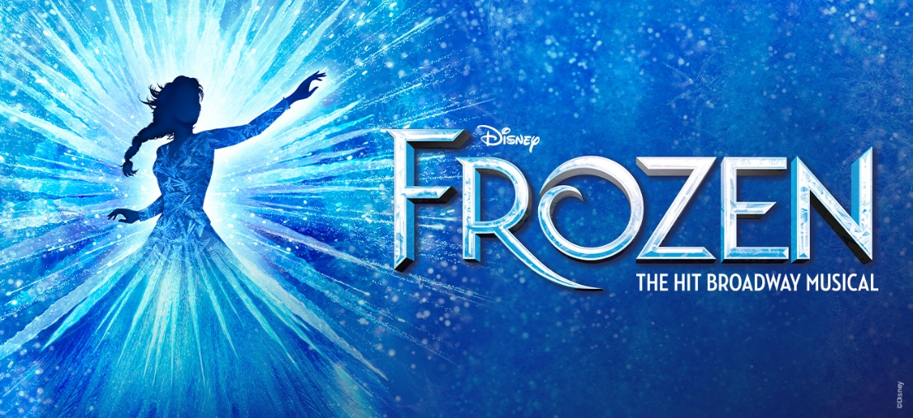

CEO OFFER:
(Pre-sale, through Jan. 11, 2022):
Use the promo code [INSERT PROMO CODE] to purchase your tickets to Disney’s FROZEN, coming to Cleveland August 11-September 11, 2022 as part of Playhouse Square’s KeyBank Broadway Series. CEO Members receive exclusive pre-sale access through January 11, 2022 to secure their seats for this Broadway megahit before the public on-sale.
GET TICKETS NOW: [INSERT LINK PROVIDED TO YOU IN EMAIL]
(On-sale, after Jan. 11, 2022):
Use the promo code [INSERT PROMO CODE] to purchase your tickets to Disney’s FROZEN, coming to Cleveland August 11-September 11, 2022 as part of Playhouse Square’s KeyBank Broadway Series. CEO Members can save up to 25% off select performances and seating locations with reduced handling fees.
GET TICKETS NOW: [INSERT LINK PROVIDED TO YOU IN EMAIL]

SHOW DESCRIPTION:
Critics are calling Disney's Frozen, “A can’t miss Broadway event” (NBC), and now it’s joining Disney’s smash hit musicals The Lion King and Aladdin on tour across North America! It features the songs you know and love from the original film plus an expanded score with a dozen new musical numbers.
Frozen is an unforgettable, magical adventure, which Newsday calls, “A serious megahit with amazing special effects, eye-popping costumes, and incredible performances.” It’s a theatrical experience like no other, so let yourself go.

