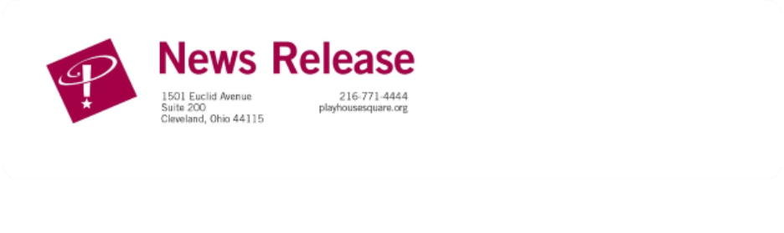

FOR IMMEDIATE RELEASE:
Media Contact: Liesl Davenport
Phone: 216-640-8677
Email: liesl.davenport@playhousesquare.org

COMEDIAN ALI SIDDIQ BRINGS THE CUSTOM FIT TOUR TO PLAYHOUSE SQUARE

The In-Demand Comic Will Bring His Brand New National Tour to Playhouse Square in Spring 2026

Tickets On Sale Now

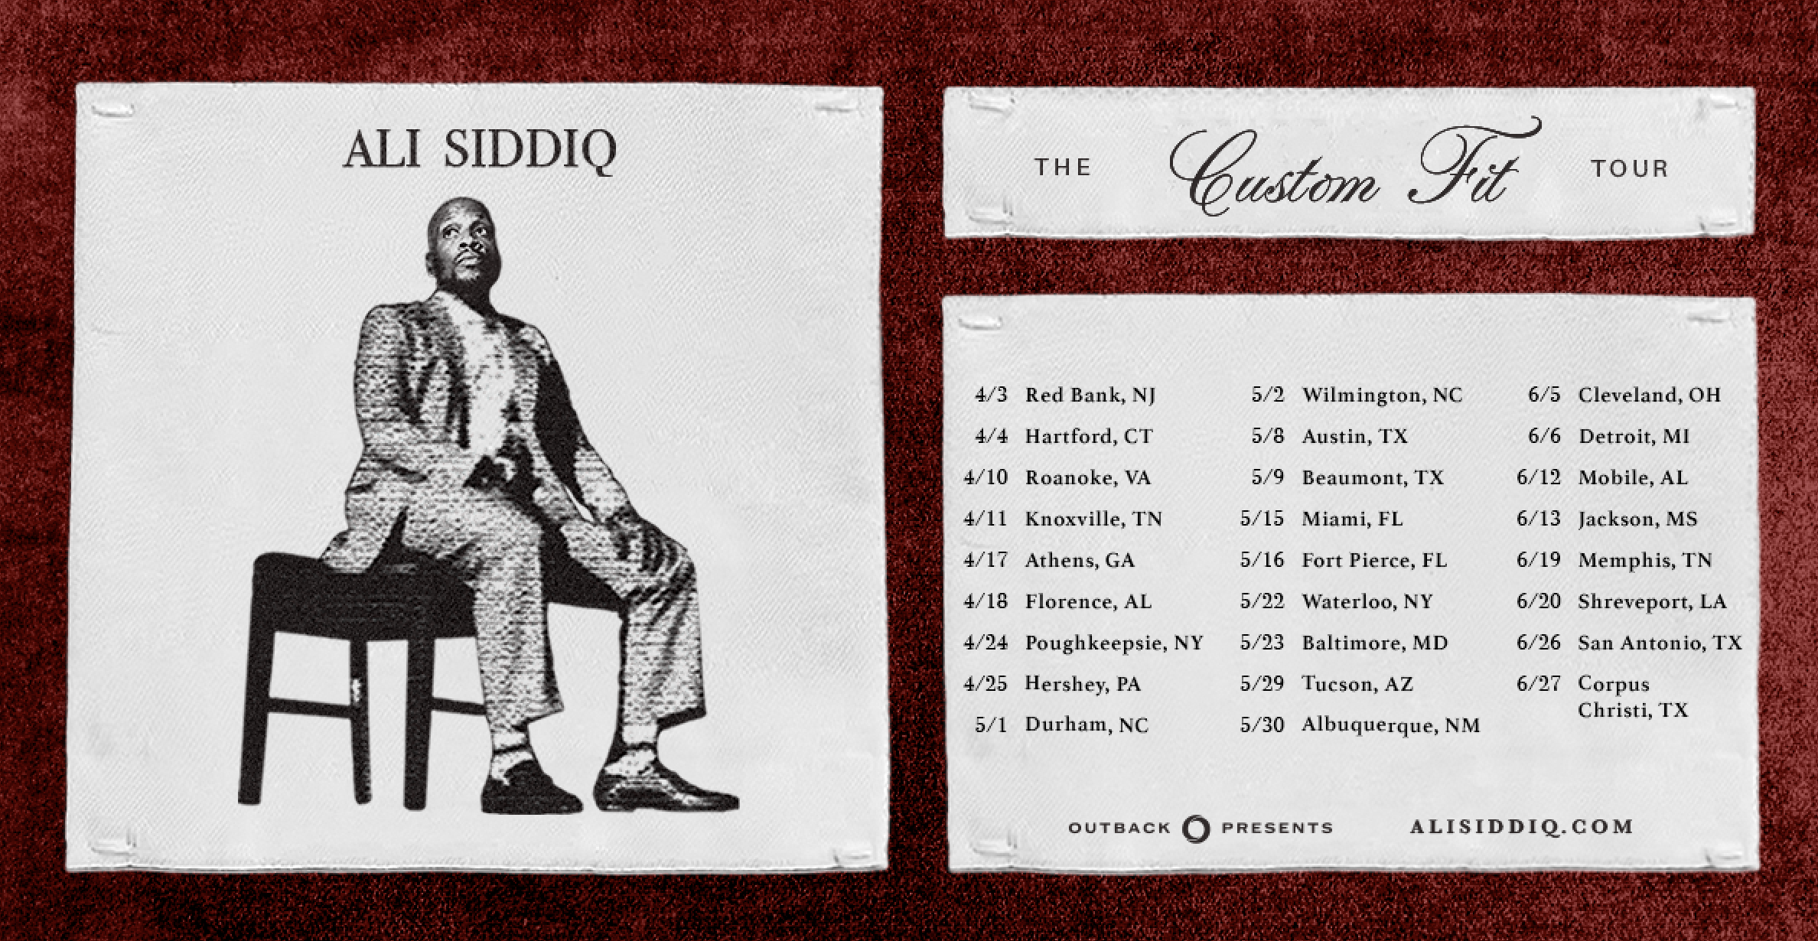
CLEVELAND, OH --- Comedian Ali Siddiq announces his brand-new national tour Ali Siddiq: Custom Fit Tour is coming to 26 markets in 2026, including a stop at Playhouse Square on June 5 at 7:00 pm. Fresh off his 2026 NAACP Image Award nomination for his standup special Ali Siddiq: My Two Sons, the only independently produced YouTube special to ever receive a major award nomination, Siddiq will perform brand new material in theaters across the country. Tickets are on sale now at playhousesquare.org.
Crowned by Vulture as “stand-up comedy’s most prolific storyteller,” Ali Siddiq has built a dedicated massive fanbase clamoring to attend his live shows and watch his masterful independently produced and released specials. He premiered his four-part stand-up series The Domino Effect 1-4 in 2022-2024 which has amassed over 47 million views. The storytelling saga cemented Ali’s reputation as a master craftsman of narrative comedy. Each chapter became a cultural event, landing Ali among the top-viewed comedians on YouTube year after year.
Also during that time, Ali released the special Don’t Judge A Book By Its Cover (2023) which has amassed 6 million views. In 2025 alone he released 3 more hour standup specials, My Two Sons (12M+ views), Rugged (7M+ views) and Mondays (3M+ views). Deadline included Ali in their list of “Comics Who Won 2025” and My Two Sons earned Siddiq a 2026 NAACP Nomination for “Outstanding Variety Series or Special.” He will be releasing 3 more new hour specials in 2026 that have already been filmed. An emerging comedy mogul, Ali also executive-produces and distributes multiple specials for other comedians including Malik S. and Ryan Davis, with a 2nd special from Marcus D. Wiley.
From Houston, TX, Ali developed his unmistakable voice in one of the most unlikely places — behind the walls of incarceration, where storytelling was survival, currency, and community. Comedy Central would later sent him back inside a Texas jail to film It’s Bigger Than These Bars (4M+ views). Today, that same voice has made him one of the most watched, respected, and consistently viral comedians in the world.
For more details and tickets visit playhousesquare.org..
Follow Ali on social media:
YouTube: @AliSiddiqComedy
Facebook: @ali.siddiq.92
Instagram: @AliSiddiq
TikTok: @TheAliSiddiq
X: @Ali_Speaks

###

Playhouse Square, the nation’s premier home for touring Broadway, is a globally recognized arts district. A not-for-profit presenter and producer of performing arts experiences, Playhouse Square is a champion of arts education and the vitality of downtown Cleveland. It proudly serves as home to eight resident companies: The City Club of Cleveland, Cleveland Ballet, Cleveland International Film Festival, Cleveland Play House, Cleveland State University Department of Theatre and Dance, DANCE Cleveland, Great Lakes Theater, and Tri-C JazzFest.

