**Media Contact:** Leigh Andreani

**Phone:** 216-640-8651

**E-mail:** [Leigh.Andreani@playhousesquare.org](mailto:Leigh.Andreani@playhousesquare.org)

**For Immediate Release**

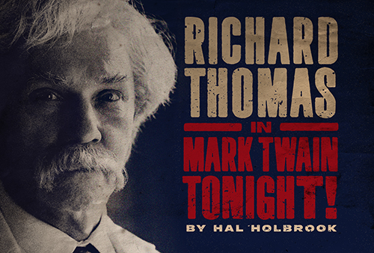

Emmy Award Winner, Tony Award Nominee and 2025 Theater Hall of Fame Inductee

Richard Thomas

to star in

*Mark Twain Tonight!*

By Hal Holbrook

At Cleveland’s Playhouse Square on October 23

Emmy-Award Winning Actor **Richard Thomas** will star in a new production of ***Mark Twain Tonight!***,coming to Playhouse Square on October 23. Tickets are now on sale at online at playhousesquare.org and by phone by calling 216-241-6000. Richard Thomas is the first and only actor authorized to perform the play, written and originally performed by Hal Holbrook.

Mark Twain’s wry humor and irreverent observations led to his being called “the nation’s one true comic genius” (*The New York Times*). Millions have cheered for the legendary one-man show, bursting with Twain’s “uproariously funny” and “pungently wise” (*Time Magazine*) commentary.

Most recently seen on Broadway in *Our Town*, on tour as “Atticus Finch” in *To Kill a Mockingbird*, and on Netflix’s *Ozark*, and recently named as a 2025 Theater Hall of Fame Inductee, **Richard Thomas** is beloved to generations as John-Boy Walton.

The creative team for ***Mark Twain Tonight!*** includes Michael Wilson, Creative Consultant; Brian Prather, Scenic Designer; Sam Fleming, Costume Designer; Anthony Pearson, Lighting Designer; Shannon Slaton, Sound Designer; Luc Verschueren for Campbell Young Associates, Hair & Wig Design. The production team includes Erin Albrecht, Production Supervisor, and Ryan Parliament, Company Manager. Hannah Rosenthal is Executive Producer.

The production will visit more than 45 cities in the 2025-26 season. For more information, please visit [www.TwainPlay.com](http://www.TwainPlay.com).

**Facts about *Mark Twain Tonight!***

* Written and performed for more than six decades on Broadway, on tour and on television by Hal Holbrook
* Played over 2,300 performances, to an audience of more than 2 million people nationwide.
* Richard Thomas is the first and only actor authorized to perform the play, written and originally performed by Hal Holbrook.
* 2026 marks the 60th anniversary of the Broadway premiere

**Biography**

**RICHARD THOMAS** won an Emmy Award and received multiple Golden Globe Award nominations for his starring role as “John-Boy Walton” in the television drama *The Waltons.* He is most recognizable to contemporary television audiences for his roles in the hit series *Ozark, The Americans, Billions*,and the original Stephen King mini-series *It*. His feature film performances include *The Unforgivable, Wonder Boys, Last Summer, Red Sky at Morning,* and *Taking Woodstock.* He has been seen in acclaimed performances on stage including the revival of *The Little Foxes*, for which he received a Tony Award nomination, *Our Town, You Can’t Take it With You, The Great Society, Race, Democracy, Incident at Vichy* (Drama Desk Award nomination), *The Stendhal Syndrome* (Lucille Lortel Award nomination, Outer Critics Circle Award nomination), *A Naked Girl on the Appian Way, An Enemy of the People, Tiny Alice, The Front Page, The Fifth of July,* innumerable Shakespeare productions, and his professional debut at 8 years old in *Sunrise at Campobello*. Across the country he has starred in the national tours of *The Humans* (Elliot Norton Award), *Twelve Angry Men*, and for three years as “Atticus Finch” in Aaron Sorkin’s *To Kill a Mockingbird*. Richard previously served as the Honorary Chair of the National Corporate Theatre Fund, a position also held by his predecessor Hal Holbrook. He is a 2025 inductee to the Theater Hall of Fame.

**#  #  #**

Playhouse Square, the nation’s premier home for touring Broadway, is a globally recognized arts district. A not-for-profit presenter and producer of performing arts experiences, Playhouse Square is a champion of arts education and the vitality of downtown Cleveland. It proudly serves as home to eight resident companies: The City Club of Cleveland, Cleveland Ballet, Cleveland International Film Festival, Cleveland Play House, Cleveland State University Department of Theatre and Dance, DANCE Cleveland, Great Lakes Theater, and Tri-C JazzFest.