**FOR IMMEDIATE RELEASE:**

**Media Contact:** Liesl Davenport

**Phone:** 216-640-8677

**Email:** [liesl.davenport@playhousesquare.org](mailto:liesl.davenport@playhousesquare.org)

**Avatar: The Last Airbender In Concert – The 20th Anniversary Tour Takes Flight This Fall**

***The Franchise’s Milestone 20th Anniversary Celebration Continues as The Music of Avatar Comes to Life on Stage at Playhouse Square***

***Tickets are On Sale Now at PlayhouseSquare.org***

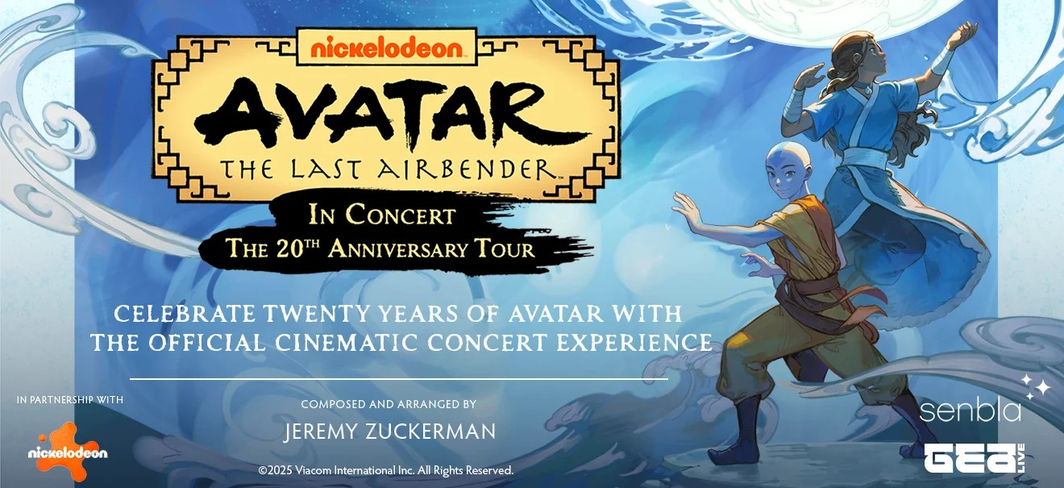

[***Press Assets***](https://drive.google.com/drive/folders/1LiAiXZxJz27JD5k7zQ4w46_WLEclHcvK?usp=sharing)

[***Watch the trailer here***](https://vimeo.com/1077948599/2fe6d9f401)

**Cleveland, OH – APRIL 29, 2025** – Nickelodeon, GEA Live, and Senbla today announced **Avatar: The Last Airbender In Concert – The 20th Anniversary Tour** [(www.avatarinconcert.com)](http://www.avatarinconcert.com/) will land in Cleveland at Playhouse Sqaure on October 1 at 7:30 p.m. Audiences will be immersed in a two-hour performance with a live orchestra that brings the show’s iconic musical score to life in perfect harmony paired with visual highlights and favorite moments from all three seasons of the series. The news comes as Nickelodeon celebrates the milestone 20th anniversary of *Avatar: The Last Airbender* with all-new original digital content across the Paramount ecosystem, one-of-a-kind experiences, and brand new consumer products and games.

Tickets are on sale now at [playhousesquare.org](http://www.playhousesquare.org/) and by phone at 216-241-6000.

Since its debut on February 21, 2005, *Avatar: The Last Airbender* has become a fixture with fans around the world, spawning a universe of popular characters, a spinoff series with *The Legend of Korra,* a recently announced new series, *Avatar: Seven Havens*, several bestselling book series, an upcoming theatrical film, and a live orchestra tour, **Avatar: The Last Airbender In Concert.**

“Avatar: The Last Airbender In Concert marks the 20th anniversary of this franchise in a way that joyfully celebrates the connection fans have with the original series,” says **Pam Kaufman, President and CEO of International Markets, Global Consumer Products & Experiences, Paramount.** “We are thrilled to be able to bring this experience to new cities worldwide, with some fun surprises in store for concert attendees.”

“We’re proud to be part of the global celebration of *Avatar: The Last Airbender*’s 20th anniversary,” says **Floris Douwes, Producer and Managing Director at GEA Live** and **Ollie Rosenblatt, CEO at Senbla**. “Since the concert launched in 2024, the tour has played over 200 shows, and sold 400.000 tickets worldwide, which is a rare milestone that reflects just how deeply this series continues to resonate with fans of all ages.”

**Avatar: The Last Airbender In Concert – The 20th Anniversary Tour** presents a stunning live orchestral performance of the series’ beloved soundtrack, now elevated with a once-in-a-lifetime cinematic experience. This special anniversary edition features a two-hour visual journey through all three seasons of the iconic animated series, projected on a full-size cinema screen with new elements and artistic surprises crafted for this special anniversary edition that offers fresh perspectives on the show’s legacy.

Preserving the original dialogue and sound effects, the concert replaces the recorded score with a powerful live orchestra, performing the legendary music of Emmy® Award-winning composer Jeremy Zuckerman, the creative mastermind behind the show's original music, in perfect sync with the action on screen.

“When I started work on *Avatar: The Last Airbender*, it was a dream to have the music performed by an orchestra,” said **Zuckerman**. “Now, over 20 years later, with the concert tour, that dream has come true in a way I never could have imagined. It’s profound for me to see the *Avatar* community of fans — so wonderfully diverse — come together to celebrate the show through its music. The atmosphere of joy at the concerts is unlike anything I’ve ever experienced. I’m elated that more people will continue to share in it.”

From taiko and erhu to soaring strings and delicate woodwinds, the music comes alive alongside the adventures of Aang, Katara, Toph, Sokka, Zuko, and more, all brought together by Zuckerman’s expanded arrangements and creative collaboration with original series editor Jeff Adams. With a few inspired additions and celebratory touches designed to mark the occasion just for this milestone tour, longtime fans and newcomers alike will experience *Avatar: The Last Airbender* like never before.

For more information about Avatar: The Last Airbender In Concert, tour dates, and tickets, please visit [www.avatarinconcert.com](http://www.avatarinconcert.com/) and follow #avatarinconcert; @avatarthelastairbender on [Facebook](http://facebook.com/avatarthelastairbender/); @avatarlegends on [Instagram](https://www.instagram.com/avatarlegends/) and [TikTok](https://www.tiktok.com/@avatarlegends); and @AvatarLegends and @avatarthelastairbender on [YouTube](https://www.youtube.com/@AvatarLegends).

**About Nickelodeon**

Nickelodeon, now in its 46th year, is the number-one entertainment brand for kids. It has built a diverse, global business by putting kids first in everything it does. The brand includes television programming and production in the United States and around the world, plus consumer products, digital, location-based experiences, publishing and feature films. For more information or artwork, visit <http://www.nickpress.com>. Nickelodeon is a part of Paramount's (Nasdaq: PARA, PARAA) global portfolio of multimedia entertainment brands.

**About *Avatar: The Last Airbender***

Nickelodeon’s *Avatar: The Last Airbender emerged* from its three-season run (61 episodes), from February 2005 to July 2008, as one of the most beloved animated properties in history. Honored with a Peabody Award and Primetime Emmy, along with multiple Annie Awards and Genesis Awards, the series follows the adventures of the main protagonist Aang and his friends, who must defeat Fire Lord Ozai and end the Hundred Year War to restore balance to the Four Nations.

In addition to the series’ success, the property has also been translated into several bestselling book series, which continue to roll out new original stories. The graphic novel series has sold nearly 3M copies, and the young adult novels have spent more than 25 weeks on the New York Times bestseller list and have sold more than 700,000 copies in both print and audiobook. The series has also come to life globally through Nickelodeon-themed attractions, resorts and live experiences, including the 100-city world tour of *Avatar: The Last Airbender In Concert*, featuring a live orchestra performing the show’s iconic musical score.

**About Paramount Location-Based Entertainment & Experiences**

Paramount Location-Based Entertainment & Experiences brings Paramount’s stories and franchises to life across experiential touchpoints, including theme parks, hotel & resorts, water parks, cruises, pop-ups, attractions, themed restaurants, Broadway musicals, touring shows, and more. Driven by iconic consumer brands, Paramount Location Based Entertainment & Experiences operates globally with more than 50 restaurants, 7 hotels & resorts including Nickelodeon Punta Cana, Nickelodeon Riviera Maya and Paramount Hotels in Dubai, theme parks and family centers across the US, the UK, Spain, Germany, Australia, Italy, Belgium, China and Malaysia and stage shows including *Mean Girls The Musical*, *The SpongeBob Musical*, *Clueless, The Musical*, and the family touring hit *PAW Patrol Live*!

**About GEA Live**

GEA Live has established itself as the premier partner in location-based entertainment, combining creativity, excellence and credibility to deliver unforgettable events that bring iconic brands to life in all their glory. Working with renowned IPs from TV, film, theatre, music, gaming, and anime, GEA Live design, produces and distributes everything from symphonic and film concerts to immersive exhibitions and stage shows. With a vast portfolio of shows spanning more than 40 countries, GEA Live has collaborated with world-class brands like PlayStation, Avatar: The Last Airbender, Twilight, Dirty Dancing, Our Planet, and Demon Slayer, in addition to exclusively representing the legendary Ennio Morricone. As a trusted pillar of Sony Music’s Masterworks Live division, GEA Live has partnered with entertainment giants like Sony Pictures, Lionsgate, Viacom, and Warner Brothers, among others, delivering unparalleled value for licensors while further elevating the world’s most cherished brands.

**About Senbla**

Founded by Ollie Rosenblatt, Senbla is a London-based concert promoting and production company that operates both nationally and internationally. Senbla works across multiple forms of live entertainment from artist touring, film in concert, one off specially produced shows, outdoor concerts, Dance, family entertainment, theatre and experiential. In the artist touring and outdoor concerts world Senbla works and has previously worked with Diana Ross, Michael Buble, Burt Bacharach, Ennio Morricone, Tony Bennett, Quincy Jones, Gwen Stefani, Chemical Brothers, Duran Duran, Soft Cell, Sophie Ellis Bextor, Paolo Nutini, Joss Stone, Itzhak Perlman, Crowded House, amongst others. Senbla is one of the exclusive promoting partners for Kew The Music as well as being the exclusive promoter and producing operating business at Bath Royal Crescent and Wasing.

Senbla is also notable for promoting and producing one off special concerts that have also gone onto be broadcasted on BBC TV and Radio. These include the A Life in Song concerts with Quincy Jones, Tim Rice, Don Black and Burt Bacharach. Senbla are also the pioneers of touring and promoting ‘Films in Concerts’ throughout the UK. Senbla not only promotes but also produces and owns exclusive global licenses on in concert film experiences. Films such as Spider-man: Into The Spider- Verse and Across The Spider-Verse, The Holiday, Avatar The Last Airbender, Love Actually, Joker. Other major film titles Senbla has promoted are The Harry Potter, the Star Wars franchise, Twilight, Beauty and The Beast, La La Land, Love Actually (UK and Australia) The Godfather, Encanto and The Muppet Christmas Carol.

Senbla has also produced theatrical works such as Circus 1903, Hair, Promises Promises as well as having a financial interest in Six The Musical in North America. In the dance space Senbla work with Strictly Come Dancing stars Alijaz and Janette, Strictly Legend as well as Opera, touring Ellen Kent’s production of Madame Butterfly, Carmen and La Boheme annually. In July 2019 Sony Music acquired a majority stake in Senbla.

# # #

Playhouse Square, the nation’s premier home for touring Broadway, is a globally recognized arts district. A not-for-profit presenter and producer of performing arts experiences, Playhouse Square is a champion of arts education and the vitality of downtown Cleveland. It proudly serves as home to eight resident companies: The City Club of Cleveland, Cleveland Ballet, Cleveland International Film Festival, Cleveland Play House, Cleveland State University Department of Theatre and Dance, DANCE Cleveland, Great Lakes Theater, and Tri-C JazzFest.