**FOR IMMEDIATE RELEASE:**

**Media Contact:** Emily Christyson

**Phone:** 216-329-0180

**Email:** [Emily.christyson@playhousesquare.org](mailto:Emily.christyson@playhousesquare.org)

**JOHN CRIST ANNOUNCES 25+ DATE FALL LEG OF**

**‘JOKES FOR HUMANS TOUR’**

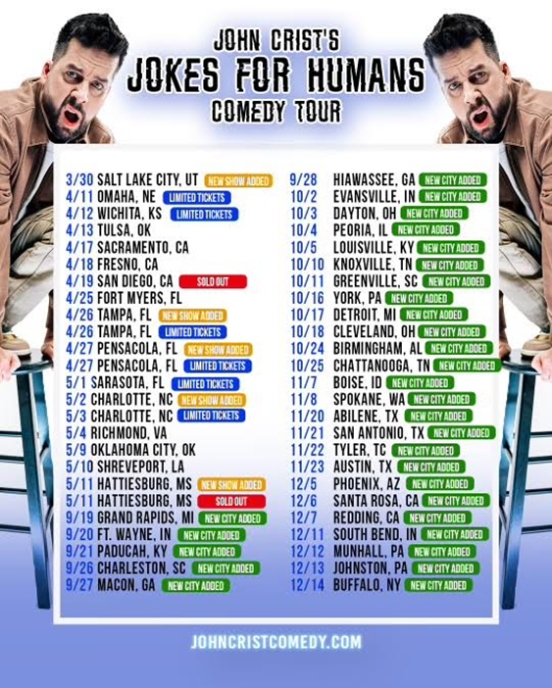

*Tickets are On Sale Now at PlayhouseSquare.org*

*Follows his highly successful*

[*‘John Crist: Emotional Support’*](https://www.youtube.com/watch?v=v8cvgqsbrbc) *comedy special (2.18)*

Cleveland, OH - [**John Crist**](https://www.instagram.com/johnbcrist/) has been a mainstay on Pollstar's Top 10 Global Touring Comedians chart, and following a nearly sold-out Spring run, he’s bringing the laughs to audiences in 25+ additional cities across the country with his 'Jokes For Humans' Fall Tour, which is making a stop at Playhouse Square on Saturday, October 18th.

Tickets are available for purchase online at [playhousesquare.org](http://www.playhousesquare.org/) or by phone at 216-241-6000.

Earlier this year, Crist released ‘John Crist: Emotional Support,’ which has been viewed more than 2.3 million times on YouTube, and more than 20 million views across social clips, since February. Watch here: [youtube.com/watch?v=v8cvgqsbrbc](https://www.youtube.com/watch?v=v8cvgqsbrbc).

Crist has more than 7.5 million combined followers due to his tastefully unhinged, yet clean, comedic takes on pop culture, offering his spoofs on family group texts, strict upbringings, sports culture and more. He recently made appearances on ***Good Morning America***, ***SHERRI Show***, ***ESPN*’s *College GameDay*** and more.

Fans can catch Crist’s conversations with fellow comedians, musicians and other celebs via his ***Net Positive Podcast***, which airs weekly, here: [youtube.com/@netpositivepod](https://www.youtube.com/@netpositivepod).

For more information on John Crist, visit [johncristcomedy.com](http://johncristcomedy.com/) or follow him on [Instagram](https://www.instagram.com/johnbcrist/), [Facebook](https://www.facebook.com/p/John-Crist-100044409040284/) and [TikTok](https://www.tiktok.com/@johncristcomedian?lang=en).

**John Crist ‘Jokes For Humans Tour’ Dates:**

Fri., Apr. 11 | Orpheum Theater | Omaha, NE

Sat., Apr. 12 | Orpheum Theatre | Wichita, KS

Sun., Apr. 13 | Tulsa Theater | Tulsa, OK

Thurs., Apr. 17 | Safe Credit Union PAC | Sacramento, CA

Fri., Apr. 18 | Saroyan Theatre | Fresno, CA

Fri., Apr. 19 | Balboa Theatre | San Diego, CA

Fri., Apr. 25 | Barbara B. Mann Performing Arts Hall | Fort Myers, FL

Sat., Apr. 26 | Tampa Theatre | Tampa, FL*

Sun., Apr. 27 | Saenger Theatre | Pensacola, FL*

Thurs., May 1 | Van Wezel Performing Arts Hall | Sarasota, FL

Fri., May 2 | Ovens Auditorium | Charlotte, NC

Sat., May 3 | Ovens Auditorium | Charlotte, NC

Sun., May 4 | Dominion Energy Center | Richmond, VA

Fri., May 9 | The Criterion | Oklahoma City, OK

Sat., May 10 | The Strand Theatre | Shreveport, LA

Sun., May 11 | Saenger Theatre | Hattiesburg, MS*

**Fri., Sept. 19 | DeVos Hall | Grand Rapids, MI**

**Sat., Sept. 20 | Embassy Theatre | Ft. Wayne, IN**

**Sun., Sept. 21 | Carson Center | Paducah, KY**

**Fri., Sept. 26 | North Charleston Performing Arts Center | Charleston, SC**

**Sat., Sept. 27 | Macon City Auditorium | Macon, GA**

**Sun., Sept. 28 | Anderson Music Hall | Hiawassee, GA**

**Thurs., Oct. 2 | Old National Events Plaza | Evansville, IN**

**Fri., Oct. 3 | Victoria Theatre | Dayton, OH**

**Sat., Oct. 4 | Peoria Civic Center Theatre | Peoria, IL**

**Sun., Oct. 5 | KY Center for the Arts | Louisville, KY**

**Fri., Oct. 10 | Knoxville Civic Auditorium | Knoxville, TN**

**Sat., Oct. 11 | Peace Center | Greenville, SC**

**Thurs., Oct. 16 | Strand Theatre | York, PA**

**Fri., Oct. 17 | Fisher Theatre | Detroit, MI**

**Sat., Oct. 18 | Connor Palace | Cleveland, OH**

**Fri., Oct. 24 | Alabama Theatre | Birmingham, AL**

**Sat., Oct. 25 | Soldiers & Sailors Memorial Auditorium | Chattanooga, TN**

**Fri., Nov. 7 | Morrison Center for the Performing Arts | Boise, ID**

**Sat., Nov. 8 | First Interstate Center for the Arts | Spokane, WA**

**Thurs., Nov. 20 | Abilene Convention Center Auditorium | Abilene, TX**

**Fri., Nov. 21 | Tobin Center for the Performing Arts | San Antonio, TX**

**Sat., Nov. 22 | UT Tyler Cowan Center | Tyler, TX**

**Sun., Nov. 23 | ACL Live at the Moddy Theatre | Austin, TX**

**Fri., Dec. 5 | Celebrity Theatre | Phoenix, AZ**

**Sat., Dec. 6 | Luther Burbank Center for the Arts | Santa Rosa, CA**

**Sun., Dec. 7 | Redding Civic Center | Redding, CA**

**Thurs., Dec. 11 | Morris Performing Arts Center | South Bend, IN**

**Fri., Dec. 12 | Carnegie of Homestead Music Hall | Munhall, PA**

**Sat., Dec. 13 | Summit Arena | Johnstown, PA \***

**Sun., Dec. 14 | UB Center for the Arts | Buffalo, NY**

*+ denotes two shows that day*

*\* denotes show on-sale April 11th*

***Fall Leg in BOLD***

###

**JOHN CRIST ON THE WEB:**

[**WEBSITE**](https://johncristcomedy.com/) | [**PRESS PAGE**](https://shorefire.com/roster/john-crist) | [**INSTAGRAM**](https://www.instagram.com/johnbcrist/) | [**TIKTOK**](https://www.tiktok.com/@johncristcomedian) | [**TWITTER**](https://twitter.com/johnbcrist) | [**YOUTUBE**](https://www.youtube.com/user/johnbcrist)

**For more information, please contact:**

Jaclyn D. Carter | Shore Fire Media | [jcarter@shorefire.com](mailto:jcarter@shorefire.com)

Olivia Troutman | Shore Fire Media | [otroutman@shorefire.com](mailto:otroutman@shorefire.com)

Jenisse Sanches | Shore Fire Media | [jsanches@shorefire.com](mailto:jsanches@shorefire.com)

*# # #*

Playhouse Square, the nation’s premier home for touring Broadway, is a globally recognized arts district. A not-for-profit presenter and producer of performing arts experiences, Playhouse Square is a champion of arts education and the vitality of downtown Cleveland. It proudly serves as home to eight resident companies: The City Club of Cleveland, Cleveland Ballet, Cleveland International Film Festival, Cleveland Play House, Cleveland State University Department of Theatre and Dance, DANCE Cleveland, Great Lakes Theater, and Tri-C JazzFest.