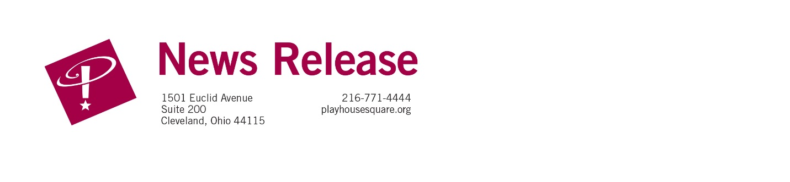
FOR IMMEDIATE RELEASE:

Media Contact: Liesl Davenport

Phone: 216-640-8677

Email: liesl.davenport@playhousesquare.org

Psychology of Cults: A Riveting Live Experience

Comes to Playhouse Square October 30

CLEVELAND, OH— Playhouse Square will host a powerful and eye-opening evening with cult interventionist and media-recognized expert Ashlen Weltz (Hilliard), MSc, PSS, in her live show Psychology of Cults on October 30. This one-night-only event dives deep into the hidden world of cults—how they form, why people join, and what it takes to break free. Tickets are on sale now at playhousesquare.org or by calling 216-241-6000.
From notorious groups like Jonestown, Heaven’s Gate, and NXIVM to lesser-known but equally dangerous organizations, Ashlen unpacks the psychological tactics and manipulation strategies that cults use to control their members. But the show goes beyond the headlines, revealing how coercion and abuse can also manifest in everyday life—within relationships, workplaces, wellness communities, and social movements.
Ashlen Weltz is one of the nation’s few Cult Intervention Specialists. She is the founder of People Leave Cults, a recovery and intervention resource for survivors and families. Her work has been featured on Hulu, NewsNation, HuffPost, and BET+, and she holds a master’s degree in the Psychology of Coercive Control. Her groundbreaking research on reproductive coercion in cults has made her a leading voice in the field.
With gripping real-life stories, expert insights, and interactive discussion, Psychology of Cults empowers audiences to recognize red flags, protect themselves, and better understand the forces that draw people into high-control groups.
Whether you’re fascinated, fearful, or just curious, this is the ultimate deep dive into one of society’s most mysterious and controversial phenomena.
Event Details:
📅 Date: October 30, 2025
📍 Location: Playhouse Square, Cleveland, OH
🎟️ Tickets: playhousesquare.org
# # #
Playhouse Square, the nation’s premier home for touring Broadway, is a globally recognized arts district. A not-for-profit presenter and producer of performing arts experiences, Playhouse Square is a champion of arts education and the vitality of downtown Cleveland. It proudly serves as home to eight resident companies: The City Club of Cleveland, Cleveland Ballet, Cleveland International Film Festival, Cleveland Play House, Cleveland State University Department of Theatre and Dance, DANCE Cleveland, Great Lakes Theater, and Tri-C JazzFest.

