**FOR IMMEDIATE RELEASE:**

**Media Contact:** Liesl Davenport

**Phone:** 216-640-8677

**Email:** [liesl.davenport@playhousesquare.org](mailto:liesl.davenport@playhousesquare.org)

**SESAME STREET LIVE TO TOUR THE U.S. AND CANADA WITH BRAND-NEW PRODUCTION WITH A SPECIAL STOP IN CLEVELAND**

*Elmo, Abby Cadabby, Cookie Monster, and their Sesame Street friends to feature in an all-new live show,* ***Sesame Street Live! Say Hello****, on November 16*

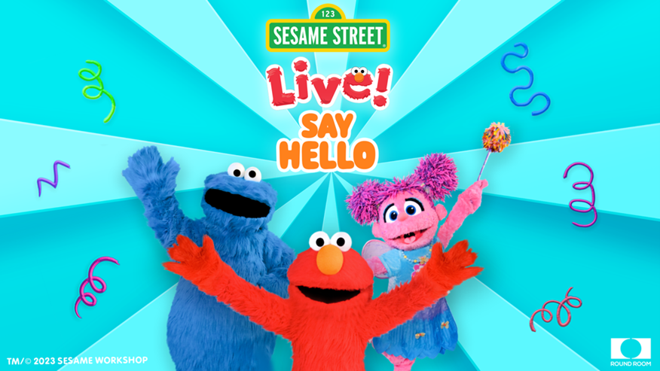

*Tickets Available for Purchase at* [*PlayhouseSquare.org*](https://www.playhousesquare.org)

**Cleveland, OH –** Round Room Live and Sesame Workshop are proud to announce a new live show, ***Sesame Street Live! Say Hello.*** The live show will bring the beloved characters from the iconic *Sesame Street* to life in a brand-new interactive production that will tour the U.S. and Canada beginning April 2024, with a stop at Playhouse Square on November 16, 2025.

Tickets for the ***Sesame Street Live! Say Hello*** are on sale now at [playhousesquare.org](http://www.playhousesquare.org/) and by phone at 216-241-6000.

Elmo, Abby Cadabby, Cookie Monster, and their friends from Sesame Street are coming to your neighborhood to say hello! At ***Sesame Street Live! Say Hello***, you can sing and dance with your favorite furry friends while enjoying fun surprises along the way. So put on your dancing shoes and make your way to where the air is sweet for this all-new celebration on Sesame Street!

“We are overjoyed and honored to be collaborating with Sesame Workshop to bring a brand-new tour of Sesame Street Live to stages across the U.S. and Canada,” said Round Room Live Founder and Co-President Stephen Shaw. “Round Room Live has a long history of exciting, innovative, and engaging productions, and we’re thrilled to combine our dedication to premium, unforgettable entertainment with the beloved characters of *Sesame Street* in an interactive musical adventure that will create memorable experiences for families of all ages.”

“For over 50 years, Sesame Workshop has worked at the intersection of education, media, and research, creating joyful experiences that enrich minds and expand hearts,” said Whit Higgins, Sesame Workshop Executive Vice President, Head of Global Enterprises. “Round Room Live has a history of working with new and iconic properties to create engaging and thrilling live events. We can’t wait for families and friends to enjoy this brand-new *Sesame Street* show filled with song, dance, and a few fun and furry surprises.”

Fans can visit SesameStreetLive.com now for tour dates and ticket information, and follow **Sesame Street Live** social media for exclusive tour content.

**FOLLOW SESAME STREET LIVE**

Official Website: [www.SesameStreetLive.com](https://www.SesameStreetLive.com)

Facebook: @SesameStreetLive

Instagram: @SesameStreetLive

TikTok: @SesameStreetLive

**FOLLOW SESAME STREET**

Official Website: [www.SesameStreet.org](http://www.sesamestreet.org/)

Facebook: @SesameStreet

Twitter: @Sesamestreet

Instagram: @sesamestreet

TikTok: @sesamestreet

**About Sesame Workshop:**  
Sesame Workshop is the global impact nonprofit behind Sesame Street and so much more. For over 50 years, we have worked at the intersection of education, media, and research, creating joyful experiences that enrich minds and expand hearts, all in service of empowering each generation to build a better world. Our beloved characters, iconic shows, outreach in communities, and more bring playful early learning to families in more than 150 countries and advance our mission to help children everywhere grow smarter, stronger, and kinder. Learn more at [www.sesameworkshop.org](https://www.sesameworkshop.org/) and follow Sesame Workshop on [Instagram](https://nam04.safelinks.protection.outlook.com/?url=https%3A%2F%2Fwww.instagram.com%2Fsesameworkshop%2F%3Fhl%3Den&data=05%7C01%7CLaura.Rigby%40sesame.org%7C7aff15146f7e461a482908dadf211da5%7C76c77645d9c44a27ad66e5a86ec55e29%7C0%7C0%7C638067630580695823%7CUnknown%7CTWFpbGZsb3d8eyJWIjoiMC4wLjAwMDAiLCJQIjoiV2luMzIiLCJBTiI6Ik1haWwiLCJXVCI6Mn0%3D%7C3000%7C%7C%7C&sdata=Hanla%2F9IqTB9Jzw7JTNfOIbNWyalESXcBY1Ngh5G4cA%3D&reserved=0), [Twitter](https://nam04.safelinks.protection.outlook.com/?url=https%3A%2F%2Ftwitter.com%2FSesameWorkshop%3Fref_src%3Dtwsrc%255Egoogle%257Ctwcamp%255Eserp%257Ctwgr%255Eauthor&data=05%7C01%7CLaura.Rigby%40sesame.org%7C7aff15146f7e461a482908dadf211da5%7C76c77645d9c44a27ad66e5a86ec55e29%7C0%7C0%7C638067630580852054%7CUnknown%7CTWFpbGZsb3d8eyJWIjoiMC4wLjAwMDAiLCJQIjoiV2luMzIiLCJBTiI6Ik1haWwiLCJXVCI6Mn0%3D%7C3000%7C%7C%7C&sdata=vgzQZIGrGyTKlxn4gRTMi%2FkOANJdm7g8igelnDnjwl8%3D&reserved=0), [Facebook](https://nam04.safelinks.protection.outlook.com/?url=https%3A%2F%2Fwww.facebook.com%2FSesameWorkshop%2F&data=05%7C01%7CLaura.Rigby%40sesame.org%7C7aff15146f7e461a482908dadf211da5%7C76c77645d9c44a27ad66e5a86ec55e29%7C0%7C0%7C638067630580852054%7CUnknown%7CTWFpbGZsb3d8eyJWIjoiMC4wLjAwMDAiLCJQIjoiV2luMzIiLCJBTiI6Ik1haWwiLCJXVCI6Mn0%3D%7C3000%7C%7C%7C&sdata=%2FE2CP9aCc0TiBg1AeEeWDBD4F7bCxwfLYmaejX%2FuOCY%3D&reserved=0), and [TikTok](https://www.tiktok.com/@sesamestreet?is_from_webapp=1&sender_device=pc).

**About Round Room Live:**

Round Room Live is the leading producer and promoter of exhibitions and family show entertainment, specializing in transforming both new and iconic intellectual property into engaging and thrilling live events. Round Room creates unique live experiences tailored to the distinct character of each property and produces the highest quality productions for audiences around the world.

Their current roster of touring theatrical shows includes: *Blippi: The Wonderful World Tour*, *Blippi The Musical* (2023 Olivier Award nomination for Best Family production)*, Sesame Street Live!*, *Peppa Pig Live*, *Shrek the Musical (2024 US Tour)*, *Nitro Circus 20th Anniversary Tour,* and *Blue’s Clues & You! Live On Stage.* Round Room’s Immersive and Entertainment Experiences division is currently touring: *Formula 1: The Exhibition, Jurassic World: The Exhibition*, *Mandela: The Official Exhibition,* and *Tupac Shakur. Wake Me When I’m Free*.

# # #

Playhouse Square, the nation’s premier home for touring Broadway, is a globally recognized arts district. A not-for-profit presenter and producer of performing arts experiences, Playhouse Square is a champion of arts education and the vitality of downtown Cleveland. It proudly serves as home to eight resident companies: The City Club of Cleveland, Cleveland Ballet, Cleveland International Film Festival, Cleveland Play House, Cleveland State University Department of Theatre and Dance, DANCE Cleveland, Great Lakes Theater, and Tri-C JazzFest.