**FOR IMMEDIATE RELEASE:**

**Media Contact:** Liesl Davenport

**Phone:** 216-640-8677

**Email:** [liesl.davenport@playhousesquare.org](mailto:liesl.davenport@playhousesquare.org)

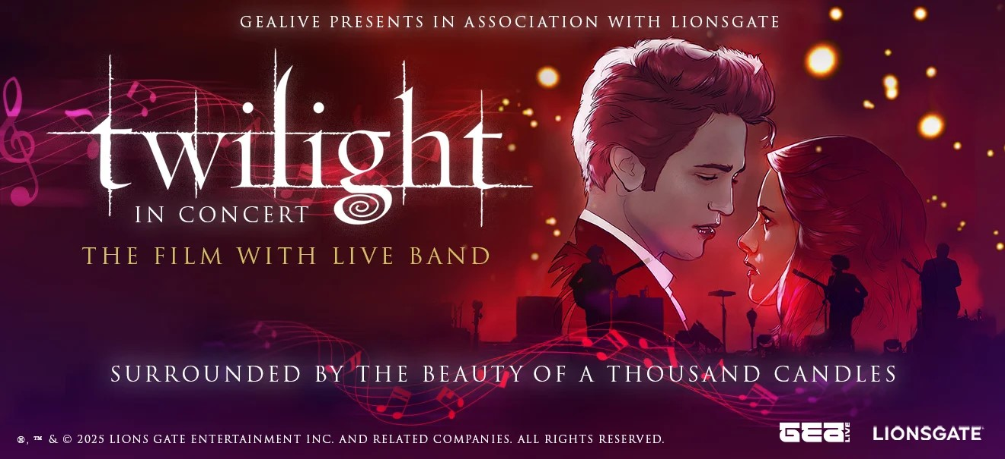

***Twilight In Concert* National Tour Visits**

**Playhouse Square on November 29, 2025**

***Experience the Legendary Romance Saga as an Epic Film-to-Concert Event, Surrounded by the Beauty of 1,000 Candles Illuminating the Stage***

***Tickets are On Sale Now at PlayhouseSquare.org***

[***Media Assets***](https://drive.google.com/drive/folders/11GbELr5gAaZhQI9otc1Jf1QpHgxFjW8J)

**Cleveland, OH–** GEA Live and Playhouse Square, in association with Lionsgate, announced the highly-anticipated 60-city national tour of the first-ever ***Twilight In Concert* (**[**www.twilightinconcert.com**](http://www.twilightinconcert.com/)**)** will visit Playhouse Square on November 29, 2025. As the novel, “Twilight”, celebrates its 20th anniversary, the live-to-film cinematic experience featuring the original movie accompanied by a 12-piece ensemble of rock and orchestral musicians on stage will transport audiences on a journey deep into the heart of this romantic story. Whether you’re Team Edward, Team Jacob, or Team Bella, ***Twilight In Concert*** promises an unforgettable evening for fans of the beloved *The Twilight Saga* film franchise -- and music enthusiasts alike.

Tickets for ***Twilight In Concert*** are on sale now and are available for purchase online at [playhousesquare.org](http://www.playhousesquare.org/) or by phone at 216-241-6000. Don't miss this opportunity to immerse yourself in the story of *Twilight* and be a part of forever!

Set in an enchanting candlelit setting, ***Twilight In Concert*** offers a unique opportunity for audiences to relive the film that started it all in a cinematic live-to-film experience with a sensational live band. Musicians will take the stage to perform the beloved film score in perfect synchronization with the original movie, presented in its entirety on a massive cinema screen. Audiences will be completely captivated by the magical atmosphere with more than one thousand twinkling candles illuminating the grand stage, creating an ambiance that sets the tone for a truly romantic evening.

For more information, tickets, and tour dates visit [www.twilightinconcert.com](http://www.twilightinconcert.com/) and follow @TwilightMovie on [Facebook](http://www.facebook.com/TwilightMovie), and @Twilight on [Instagram](https://www.instagram.com/twilight) and [X](https://x.com/Twilight).

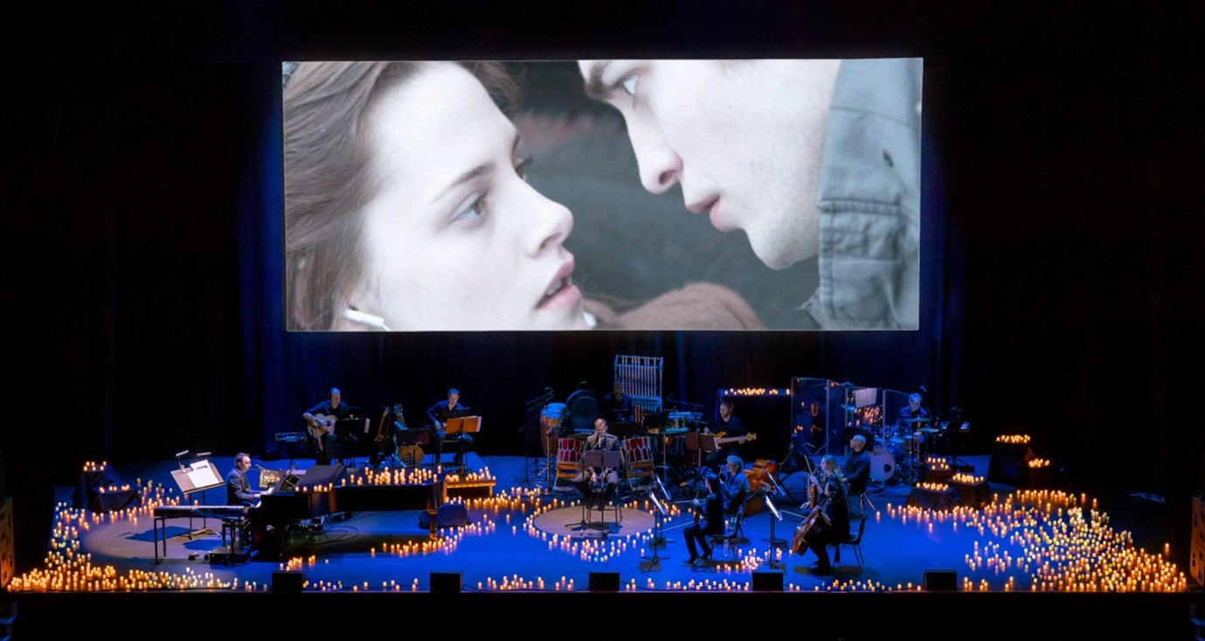

*The Twilight Saga* is one of the most successful young adult film franchises of all time. The five films (*Twilight*, *The Twilight Saga: New Moon*, *The Twilight Saga: Eclipse* and *The Twilight Saga: Breaking Dawn - Parts 1 & 2*) have grossed more than $3.3 billion at the worldwide box office. The films were adapted from “Twilight” creator Stephenie Meyer’s acclaimed series of books that won multiple awards, sold over 160 million copies worldwide and were translated into 49 different languages. Lionsgate’s TV adaptation of Stephenie Meyer’s novel “Midnight Sun” has been picked up to series at Netflix.

**About *Twilight***

Bella Swan (Kristen Stewart) doesn't expect much when she moves to the small town of Forks, Washington, until she meets the mysterious and handsome Edward Cullen (Robert Pattinson) — a boy who's hiding a dark secret: he's a vampire. As their worlds and hearts collide, Edward must battle the bloodlust raging inside him as well as a coterie of undead that would make Bella their prey. Based on the #1 NEW YORK TIMES best-selling sensation by Stephenie Meyer, TWILIGHT adds a dangerous twist to the classic story of star-crossed lovers.

**About Lionsgate Global Products & Experiences**

Lionsgate Global Products & Experiences is a division within Lionsgate Studios Corp. (Nasdaq: LION), one of the world’s leading standalone, pure play, publicly-traded content companies. By leveraging the studios’ world-class portfolio of film and television brands and franchises, the division drives incremental revenue and builds consumer engagement via live shows and experiences, location-based entertainment destinations, games, physical and digital merchandise, and select strategic partnerships and investments*.*

The group has announced multiple stage productions (*Dirty Dancing*, *La La Land*, *Wonder* and *Nashville* for Broadway, and *The Hunger Games* for London), integrations with marquee games (*Call of Duty*, *Dead By Daylight*, *Roblox,* and *Fortnite*), and collaborations with best-in-class consumer products licensees (LEGO, American Classics, Hot Toys, Funko, and more). Attractions based on Lionsgate’s top franchises *The Hunger Games*, *John Wick*, *SAW* and other iconic IP can be found at theme parks and destinations in Asia, the United States, the United Kingdom, and the Middle East, with the highly anticipated *John Wick Experience* now open in Las Vegas.

**About GEA Live**

GEA Live has established itself as the premier partner in location-based entertainment, combining creativity, excellence and credibility to deliver unforgettable events that bring iconic brands to life in all their glory. Working with renowned IPs from TV, film, theatre, music, gaming, and anime, GEA Live design, produces and distributes everything from symphonic and film concerts to immersive exhibitions and stage shows. With a vast portfolio of shows spanning more than 40 countries, GEA Live has collaborated with world-class brands like PlayStation, Avatar: The Last Airbender, Twilight, Dirty Dancing, Our Planet, and Demon Slayer, in addition to exclusively representing the legendary Ennio Morricone. As a trusted pillar of Sony Music’s Masterworks Live division, GEA Live has partnered with entertainment giants like Sony Pictures, Lionsgate, Viacom, and Warner Brothers, among others, delivering unparalleled value for licensors while further elevating the world’s most cherished brands.

# # #

Playhouse Square, the nation’s premier home for touring Broadway, is a globally recognized arts district. A not-for-profit presenter and producer of performing arts experiences, Playhouse Square is a champion of arts education and the vitality of downtown Cleveland. It proudly serves as home to eight resident companies: The City Club of Cleveland, Cleveland Ballet, Cleveland International Film Festival, Cleveland Play House, Cleveland State University Department of Theatre and Dance, DANCE Cleveland, Great Lakes Theater, and Tri-C JazzFest.