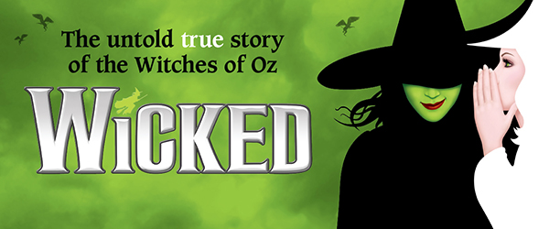

SHOW DESCRIPTION:
WICKED, the Broadway sensation, looks at what happened in the Land of Oz…but from a different angle. Long before Dorothy arrives, there is another young woman, born with emerald-green skin—smart, fiery, misunderstood, and possessing an extraordinary talent. When she meets a bubbly blonde who is exceptionally popular, their initial rivalry turns into the unlikeliest of friendships…until the world decides to call one “good,” and the other one “wicked.”
From the first electrifying note to the final breathtaking moment, WICKED—the untold true story of the Witches of Oz—transfixes audiences with its wildly inventive story that USA Today cheers is “a complete triumph! An original musical that will make you laugh, cry, and think.”
SUGGESTED SOCIAL MEDIA CAPTIONS:
“WICKED is flying back to Cleveland and I've reserved a block of tickets! Contact me if you'd like to be part of my group!”
“Joining my group for WICKED at Playhouse Square might just make you slightly more Popular... Contact me for details!”
"Don't miss your Chance to Fly. Contact me to join my group for WICKED at Playhouse Square!"
"You don't have to Defy Gravity for great seats to WICKED at Playhouse Square. Join my group!"

